KAZAKH INVEST: investors’ support and services are available 24/7

The Government of Kazakhstan has declared a state of emergency to contain the coronavirus outbreak in view of the World Health Organization declaring COVID-19 a pandemic on 11 March 2020 and in the efforts to protect life and health of the citizens. The Decree of the President of the Republic of Kazakhstan No. 285 dated 15 March 2020 has introduced a state of emergency throughout the country starting from 08:00 a.m. on 16 March 2020 up to 07:00 a.m. on 15 April 2020.
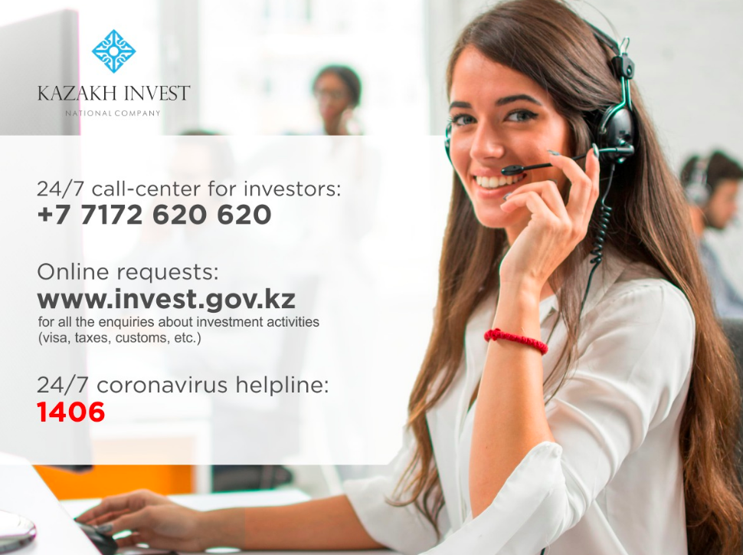

INFORMATION ON CORONAVIRUS
The 24/7 coronavirus helpline of the National Center for Public Health of the Ministry of Health of the Republic of Kazakhstan: 1406, 8 7172 768 043.
Telegram bot “Coronavirus hotline” contains basic information about COVID-19 infection (information on the infection, transmission routes, symptoms, incubation period, how to protect yourself from infection, etc.). The bot is available in two languages: Russian and Kazakh.

QUARANTINE IN NUR-SULTAN AND ALMATY
The State Commission on ensuring the state of emergency under the President of the Republic of Kazakhstan introduced the quarantine regime and implementation of the large-scale sanitary and anti-epidemic measures in the cities of Nur-Sultan and Almaty starting from 19 March 2020. The measures impose restrictions on the movement of people as well as the entry / exit of vehicles within quarantine zones.
For more information on the quarantine regime, please visit the official website of the Government of the Republic of Kazakhstan.

SERVICE SUPPORT FOR INVESTORS
Service support for investors as well as consultations on investment activities (visa, tax, customs issues, etc.) are provided 24/7 by KAZAKH INVEST call-center: +7 7172 620 620.
You can also submit a request for consultation using the online request form on www.invest.gov.kz.
You can find information on the Government support measures for foreign investors in the “Investor's Guide” section of the website. The section provides relevant information with the respective links to the official legal database. Additionally, KAZAKH INVEST experts are ready to provide you comprehensive advice on any issues.
For KAZAKH INVEST incoming correspondence, please call: +7 7172 620 627.

ARRIVING TO KAZAKHSTAN
Detailed information on visa issuance and arriving to Kazakhstan is available on www.invest.gov.kz in the "Arriving to Kazakhstan" section.
A detailed consultation of a KAZAKH INVEST specialist on visa and migration issues can be obtained by calling: +7 7172 620 556.
Please note that Kazakhstan has introduced the state of emergency, which restricts the entry of foreign citizens into the country starting from 16 March 2020. For more information on restrictions on entry and exit from the territory of the Republic of Kazakhstan, please visit the official website of the Ministry of Foreign Affairs of the Republic of Kazakhstan.

FREIGHT TRANSPORTATION
The state of emergency does not impose any restrictions on freight transportations. However, the sanitary-epidemiological regime has been strengthened
at the border-crossing checkpoints, railway stations and airports,.
For any questions about freigh transportation during the state of emergency, please contact call center of KTZ - Freight Transportation JSC: +7 7172 603 030.

EMERGENCY OPERATIONAL SERVICES
If you require emergency services, you can report a problem by contacting the following numbers:

• fire service - 101
• police - 102
• ambulance - 103
• gas network emergency service - 104
• emergency response service - 112

